Luna Bloom Online Shopping Site

Introduction

Online shopping has revolutionized the way consumers purchase goods and services, offering convenience, variety, and accessibility from the comfort of one's home. Over the last two decades, it has become a dominant retail method, enabling businesses to reach customers worldwide through websites and mobile applications.

The evolution of e-commerce platforms like Amazon, Myntra, and others has paved the way for a seamless shopping experience, combining sophisticated technology with user-friendly interfaces. Customers can browse products, read reviews, compare prices, and complete purchases with just a few clicks, making online shopping an integral part of modern consumer behavior.

This transition from traditional brick-and-mortar stores to online marketplaces has also shifted businesses' strategies, focusing on digital marketing, personalized shopping experiences, and leveraging advanced logistics for fast delivery. For consumers, online shopping offers the convenience of 24/7 access, a wide range of products, and services that cater to their specific needs.

Building a website similar to platforms like Amazon and Myntra requires a comprehensive understanding of user experience, digital infrastructure, and secure payment systems to ensure success in a highly competitive and dynamic market.

Problem Definition

A boutique Java project typically refers to a small, specialized software application or system. Crafting a problem statement for such a project should focus on addressing a specific, real-world issue or improving an existing process through software development. Here are a few potential problem statements for a boutique Java project:

1. Inventory Management System for Local Boutiques

Problem Statement: Small boutique stores often struggle with inventory management due to reliance on manual processes or outdated systems. This can lead to issues like stock shortages, overstocking, and difficulty tracking sales trends. The project aims to develop a lightweight Java-based inventory management system tailored for small boutiques, allowing store owners to track stock levels, receive low-stock alerts, and analyze sales data in real-time.

2. Personalized Recommendation System for Niche Online Stores

Problem Statement: Niche online stores often struggle to provide relevant product recommendations due to limited customer data and lack of advanced recommendation algorithms. This project will develop a personalized recommendation engine using Java that leverages customer browsing and purchase history to suggest products, improving customer satisfaction and increasing sales.

3. Customer Relationship Management (CRM) for Small Businesses

Problem Statement: Many small businesses cannot afford complex CRM software used by larger enterprises, but still need efficient ways to manage customer relationships, track interactions, and automate follow-up actions. The project will build a Java-based CRM platform that is affordable, easy to use, and focuses on the essential CRM functions for small businesses like boutiques.

4. Event-Driven Order Processing System

Problem Statement: Small boutiques offering online sales may face challenges in automating order processing, leading to delays, manual errors, and dissatisfied customers. This project aims to create a Java-based event-driven system that automates the entire order process—from order receipt to shipment—while integrating with third-party services like payment gateways and shipment tracking systems.

5. Mobile Application for Boutique Storefronts

Problem Statement: Small boutique shops often lack the resources to build their own mobile applications, missing out on the mobile shopping trend. This project will create a modular Java-based mobile app template for boutique stores, enabling them to showcase their products, handle mobile orders, and offer customer loyalty programs through a cost-effective solution.

6. Automated Analytics and Reporting Tool for Small Businesses

Problem Statement: Small businesses often lack access to complex analytical tools for understanding customer behavior and business performance. This project will develop a Java-based application that automatically collects, processes, and generates reports on key performance indicators (KPIs) like sales trends, customer demographics, and product performance, tailored for small boutiques.

Modules

Implementation

Start page

R1.setBounds(120,140,100,20);

JRadioButton r2 = new JRadioButton(“Female”);

R2.setBounds(220,140,100,20);

@SuppressWarnings(“rawtypes”)

String country[]={“India”,”Aus”,”U.S.A”,”England”,”Newzealand”};

JComboBox<String> cb=new JComboBox<>(country);

Cb.setBounds(120,170,100,20);

JTextArea address = new JTextArea();

Address.setFont(new Font(“Arial”,Font.PLAIN,15));

Address.setBounds(120,220,300,180);

Address.setLineWrap(true);

JPasswordField value = new JPasswordField();

Value.setBounds(120,430,100,20);

JButton b = new JButton(“Submit”);

b.setBounds(120,480,80,30);

f.add(name);

f.add(email);

f.add(age);

f.add(gender);

f.add(r1);

f.add(r2);

f.add(nametx);

f.add(emailtx);

f.add(agetx);

f.add(nation);

f.add(cb);

f.add(resad);

f.add(address);

f.add(pass);

f.add(value);

f.add(b);

f.add(label1);

f.add(label2);

f.add(label3);

f.add(label4);

f.setSize(400,400);

f.setLayout(null);

f.setVisible(true);

b.addActionListener(new ActionListener(){

@Override

Public void actionPerformed(ActionEvent e) {

String username = “Name: “+ nametx.getText();

//data += “Password:” + new String(value.getPassword());

Label1.setText(username);

String email = “Email: “+ emailtx.getText();

Label2.setText(email);

String pswd = “Password: “+new String(value.getPassword());

Label3.setText(pswd);

String adrs = “Address: “+ address.getText();

Label4.setText(adrs);

}

});

}

}

Add to cart page

removed from cart!");  
                    }  
                } else if (choice == 1) {  
                    // Clear cart  
                    int confirm = JOptionPane.showConfirmDialog(  
                            OnlineShoppingFrame.this,  
                            "Are you sure you want to clear the entire cart?",  
                            "Clear Cart",  
                            JOptionPane.YES_NO_OPTION);  
                    if (confirm == JOptionPane.YES_OPTION) {  
                        cartItems.clear();  
                        JOptionPane.showMessageDialog(OnlineShoppingFrame.this,  
                                "Your cart has been cleared!");  
                    }  
                }  
            }  
        }  
    }  
}

Result

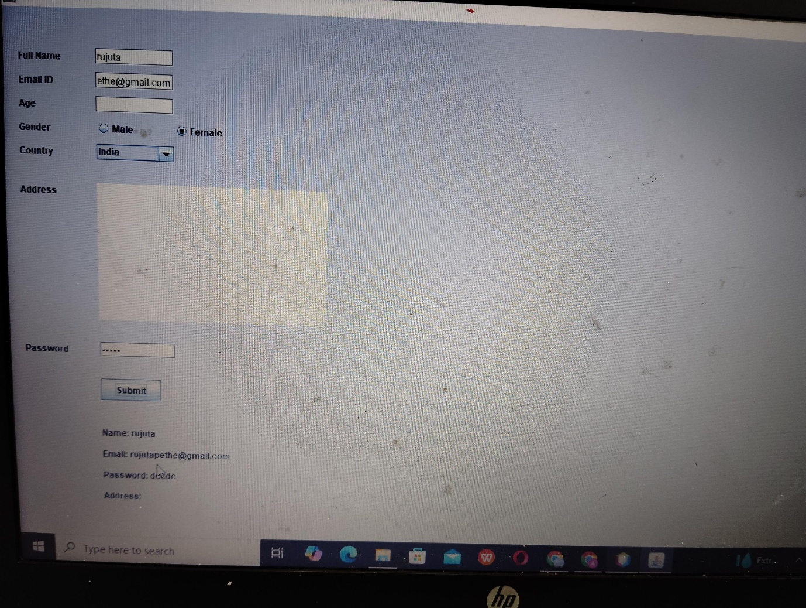

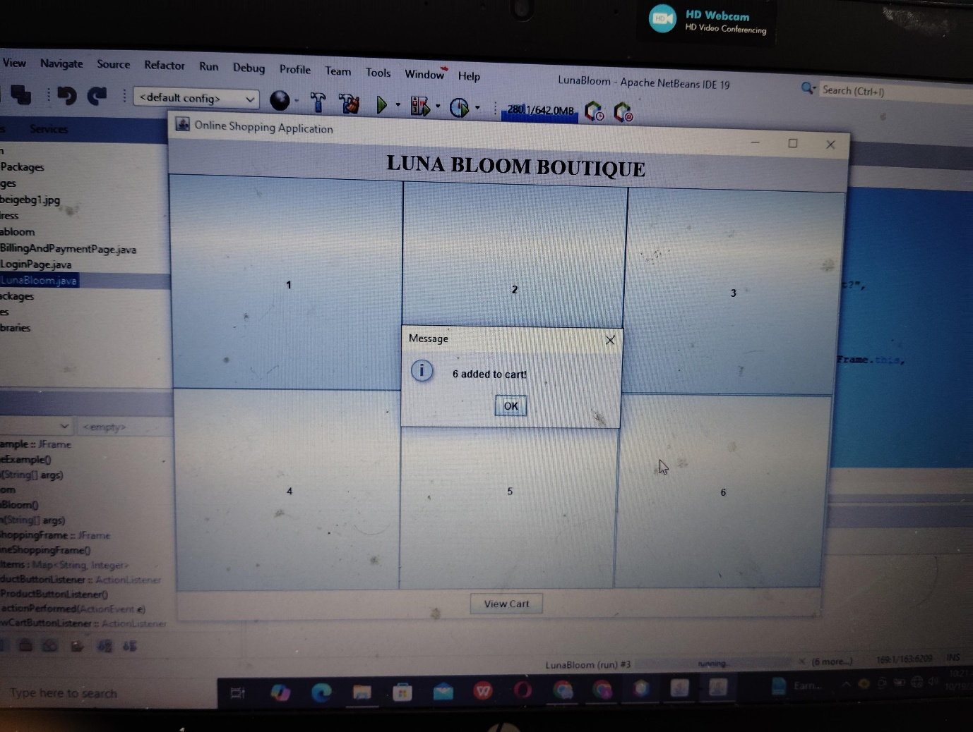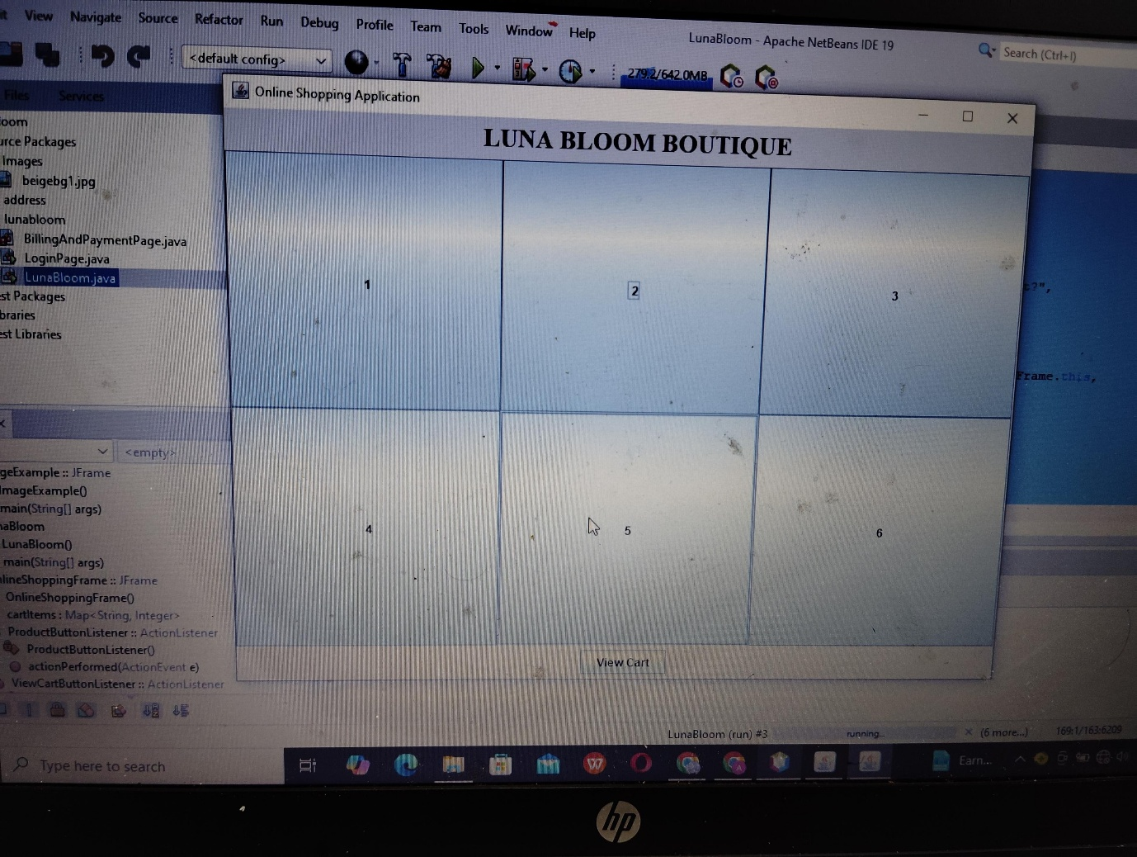

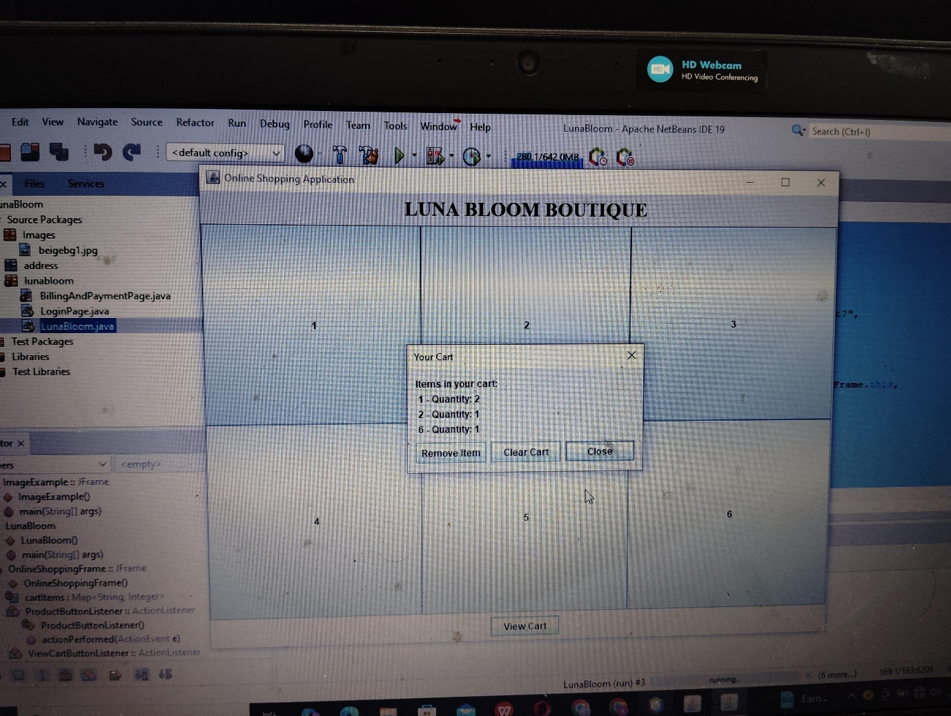

Conclusion

Our basic online shopping website, developed using NetBeans, offers a simple and functional platform for users to browse and purchase products. While it is a foundational version, it demonstrates the core elements of e-commerce, including product listing, a shopping cart, and basic checkout functionality.

This project lays the groundwork for future enhancements, providing a solid structure to build upon as we expand features and improve user experience.